### M4 Status Updates

**Effects of CO2 emissions on temperature in USA by State**

Parth Patel - ppatel92@gatech.edu

Shafiq Mohammed - shafiq@gatech.edu

**What we’ve gotten done so far**

So far, we have learned how to use D3, discovered some useful libraries that are related to our project, and have created a basic structure of what our final visualization will look like. This includes revising our initial proposed solution per the feedback we received from the professor and working towards a tangible design. This entailed consolidating our initially proposed four choropleth maps into two which reflect differences in the attributes between the two selected dates. The choropleth maps are maps of the United States, broken down into states, that are highlighted with a different color when you hover over them, as well as reveal the name of the state.

Along with the above revision, we have been experimenting with using a double-line graph and were able to create one using D3. Although we haven’t been able to consolidate that into our infovis yet due to pixel constraints (we created it on a separate screen, as shown below), we are planning on figuring out the details and incorporating it into our infovis very soon.

**What obstacles we have encountered**

One major obstacle that we encountered was that our three-man team was broken down into a two-man team because one of our team members dropped the course. Initially, our milestones were planned with the consideration that this project will be a three-man project, and therefore we planned our milestones accordingly. However, since one of our team members dropped, we were unable to meet certain milestones, which I will detail below. Along with that, a minor obstacle was that based on the feedback we received, we had to change some parts of our milestone (detailed below), and thus spent more time planning than we did constructing our project.

**Whether/how our plans have changed as we have gotten to work**

As mentioned above, our plans changed significantly due to two factors: (1) based on the feedback we received from the professor and (2) based on the circumstance of one of our team members dropping the class. How they have changed are detailed in the next section.

**Progress in milestone, schedule updates**

***June 26- Milestone 1: Requirements gathering milestone. This entails the team learning about D3 and coming up with a tangible idea on how to approach our solution with code in mind.***

We were able to learn about D3 and come up with a proposed solution and therefore met this milestone on time. Along with that, we researched potential D3 libraries that would be useful for our project, and we found the DataMaps library that relies heavily on D3. Along with that, we also found the D3Slider library to implement the suggested dual slider to pick a date range.

***June 30- Milestone 2: Have the first idiom, the two choropleth graphs which display the temperature data developed and functioning.***

We ended up consolidating the two choropleth graphs that show the values for those dates into one that displays the difference between the two values. However, we have not been able to create the backend functionality yet, which we are working on.

***July 3- Milestone 3: Have the second idiom, the two choropleth graphs which displays the CO2 emissions data developed and functioning.***

Same as above. We consolidated the two choropleth graphs into one, were able to create a functioning design, but have yet to create the backend functionality yet.

***July 8th- Milestone 4: Have the third idiom, the multiple line graph which helps us see the trends of both the average temperature range and CO2 emissions encoded.***

We have the design part coded up, but again, we have not yet implemented backend functionality yet.

So in summary, milestones 1, 2, and 3 have been met on the frontend side, but the backend still needs to be implemented. Therefore, the one change I would make to the above is to modify milestone 4 to reflect having backend functionality implemented, since we already have the front-end design implemented.

**Modifications to proposed implementation approach**

This has already been mentioned in the above sections. We got rid of the 4 choropleth maps and replaced them with two that display the differences between the values from the two selected years instead. Moreover, we changed the date picker to a dual slider, which can be seen below (although in the screenshot taken, it looks as if there is only one date adjuster, whereas it’s resting on top of the other one).

**Current interface screenshots**

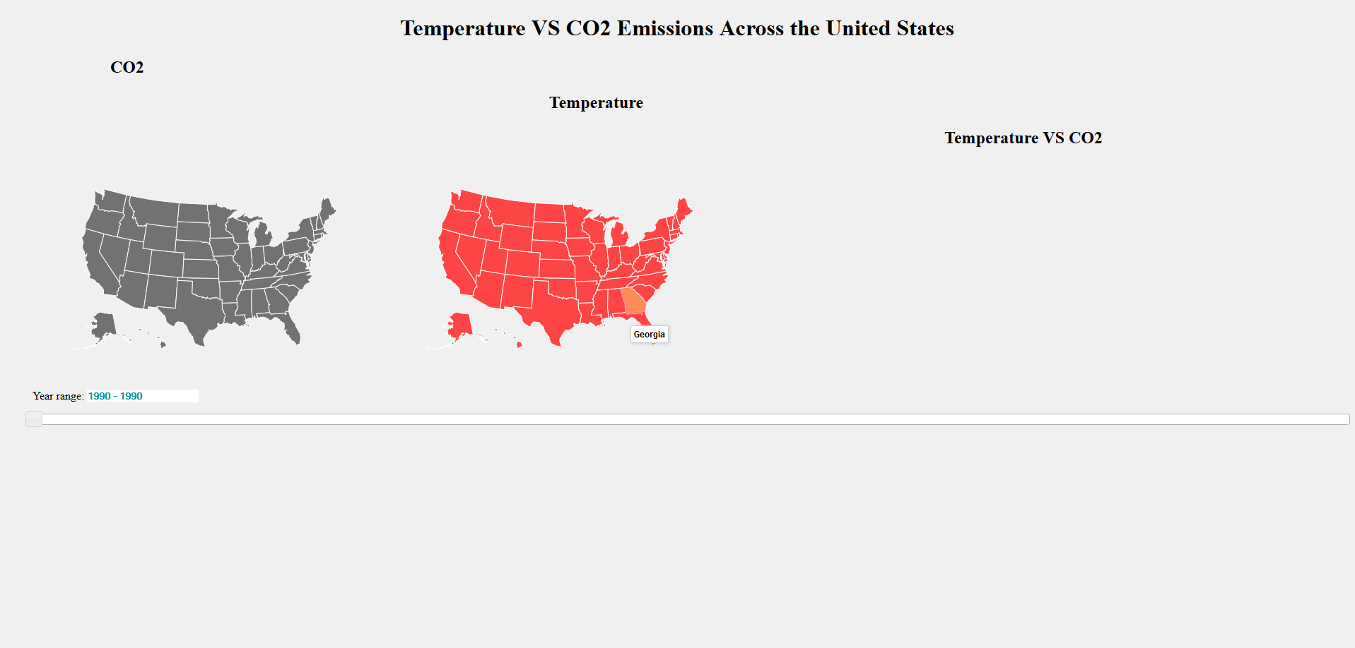

*Figure 1: The two choropleth maps have been designed, with space left on the right for the graph below. The slider has also been implemented, but it’s aesthetics will be improved upon later on once we implement the functionality of the maps.*

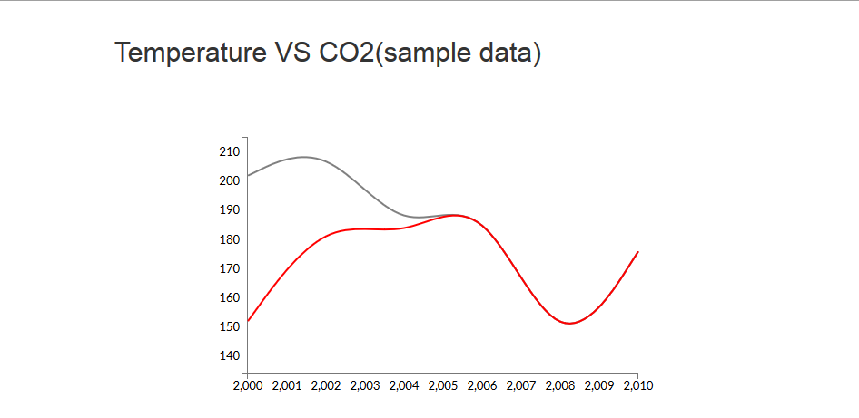

*Figure 2: The double line chart which will display the correlation between the CO2 levels and the temperature. The values on the Y-axis are still being worked on (e.g. how to best represent the values), therefore, the values are going to change once this is implemented into Figure 1.*